Clear Customer Down Payment

S.NO : 02-FI-AR-02

TRANSACTION CODE : F – 39

ACCESSB PATH : SAP Easy Access Accounting Financial
Accounting Accounts Receivable Document
Entry Down payment Clearing

We get “ Clear Customer Down Payment – Header Data” Screen

Required Fields:

Document date : To be entered
Account : To be entered (Customer A/c Number)
Posting date : Default
Fiscal Year : Default

Rest all other fields viz, Doc Type, Period, Companycode,Currency/Rate are default after they are entered for the first time

We get the Screen “Clear Customer Down Payment - Header Data“ incorporating the above mentioned required fields as under;

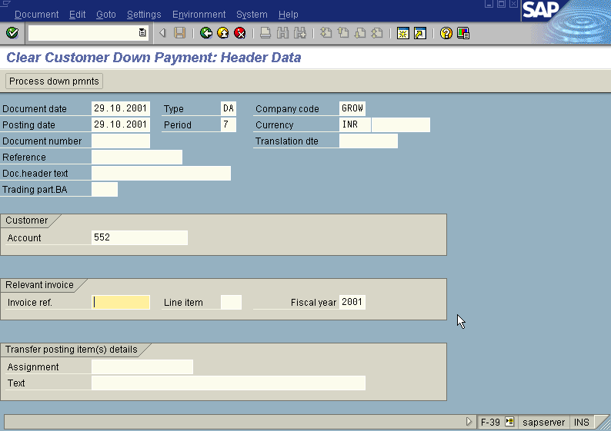

From the above “Clear Vendor Down Payment - Header Data“ screen before pressing enter button one point that has to be kept in mind is deletion of invoice number which is appearing as default under section Relevant invoice in the “Clear Customer Down Payment - Header Data” screen.

Press Enter button

We will be presented with “ Clear Customer Down Payment – Choose Down Payments” screen as below;

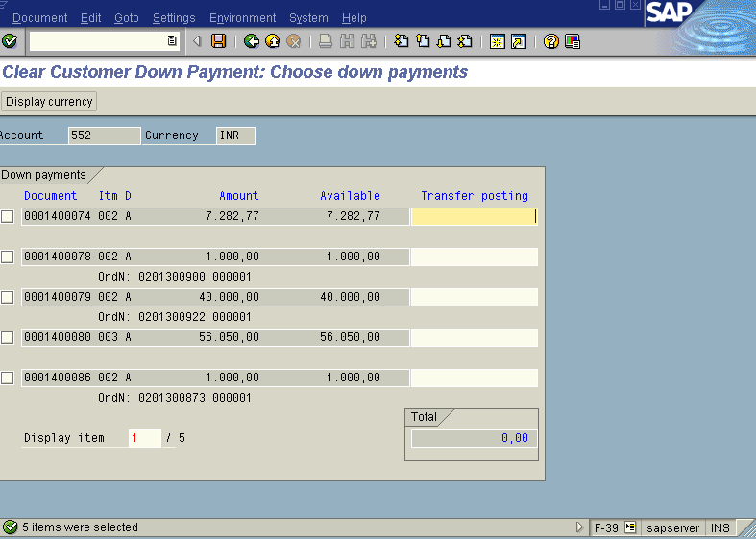

Press Page Down Button from Key board till the point you find the Down payment/s which are to be cleared from the above “ Clear Customer Down Payment – Choose Down Payments” screen. Once you have found the down payment you wanted to clear just put a tick mark on the check box appearing to the left side of down payments list as in the screen shown below;

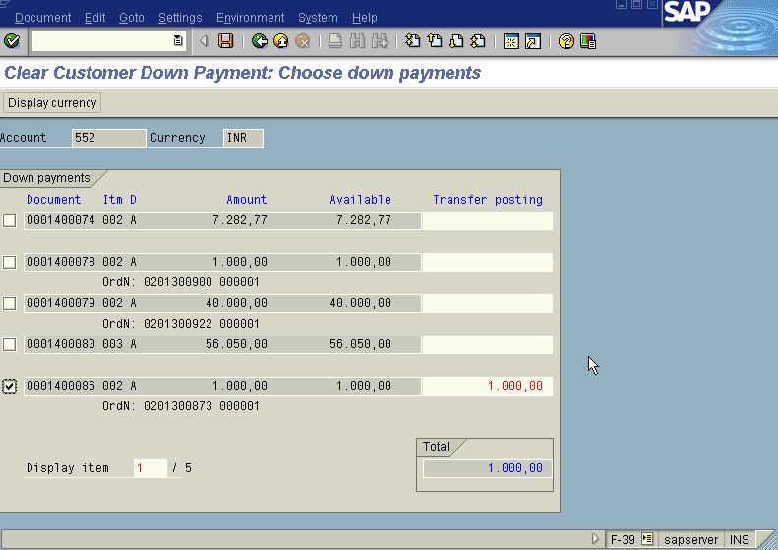

Press Save button

We will get “ Clear Customer Down Payment – Display Overview” screen as below with a message “ correct the marked line items at the bottom with a green tick as below;

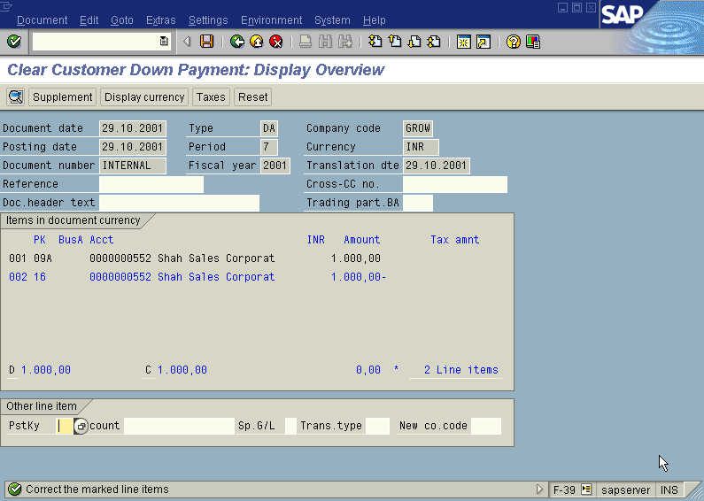

In the above “ Clear Customer Down Payment – Display Overview” screen , just double click with the mouse on the blue colour highlited line item. We will get the
“ Clear Customer Down Payment – Correct Customer Item” screen as displayed below with symbol under Text field.

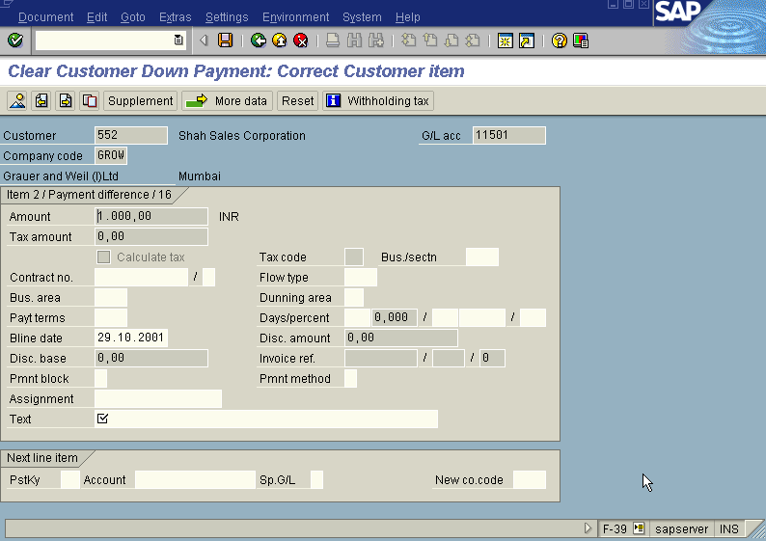

Fill the Text field with appropriate text in the above “ Clear Customer Down Payment – correct Customer Item” screen.
Press Save button

The system will display a message as under

Take a note of the document number ; 1600075

This is the stage where “clearing Customer down payment” stage is complete

The document can be seen from Document Display from the top left hand side of the main screen “post Customer down payment - Header Data“ OR from Transaction code FB- 03 .The Document overview screen will be displayed as under showing the entries.

